Phase 3
Article interviews
So we have interviewed our parents and grandparents, and these are the people we have interviewed:
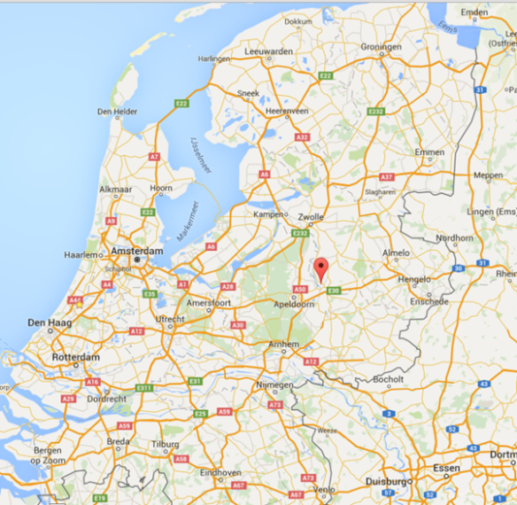
- Grandfather Henk Bruil of Jesse Grim, he has 1 brother and 1 sister, and they lived in the house of his grandfather with 5 people. His father (1908) worked at the Dutch Telephone Company. He lived in Deventer (see map)

- Father Ruud Grim of Jesse Grim, there were 5 people in his parents family, and they lived with 5 people in the same house. His father was is sales advertisement; His mother was administrator but stopped working when he was born. He first lived in The Hague, and when he was 15 they moved to Leiderdorp. (see map)

- Grandmother Ria Kerstens of Desiree van der Sar, there were 8 people in her parents family, and they lived with 8 people in the same house. Her mother was a housewife and her father was a plasterer. She lived in Breda (see map)

- Father Ben van der Sar of Desiree van der Sar, there were 4 people in his parents family, and they lived with 4 people in the same house. His father was an official at the municipality and his mother was a housewife. He lived in Rijswijk (see map).

- Grandfather Floor van Nes of Floris Haverman. There were 6 people in his parents family, and they lived in their grandparents house with 6 people. His mother was a housewife and his father worked at an oil refinery. He lived in Vlaardingen (see map)

- Mother Nicole van Nes of Floris Haverman. There were 5 people in her parents family, and they lived with 5 people in the same house. Her father was a mathematician and her mother a teacher. She lived in Voorschoten. (see map)

The interviews
So we interviewed them and compared them. This is what we saw:
There are some similarities between the grandparents, for example:
- They all had more than 4 people in the house like it is now, the parents had around 6-8 people in the same house
- one of the main values taught were honesty, and have respect to each other and help each other
- they all liked the cosines and freedom in the family
but there are still some differences:
- lived/live all at completely different town/villages
- they all have a different most import historical event .
- the hierarchy was very different; in one family the duties were equal divided among the children and the parents arranged together the business, but in the other family the children had nothing to say.
What we see from this is that there are lots of differences but the most important things in a family aren’t really different. Like the main values and freedom. This way we can conclude families in the Netherlands aren’t that different, even if they come from total different parts of the Netherlands.

For the parents, the similarities were:
- They all lived with 4 or 5 people in one house
- They were not very dominant hierarchy in all families; sometimes or on some areas there was hierarchy.
- They all think that people now a days are buzzier. Within most families 2 parents working and less time spending with their children.
But still some differences:
- One of the three did discuses things with the family they discussed where they went on holyday and how much money could be spend on clothes.
- They were all told totally different lessons. from believe in yourself to be honest and work hard to respect everyone whatever oddities they have
- They liked different things about their families. One liked to play games with the family like monopoly. The other one liked the thrust in the family and the freedom they got to develop in the person they want to became. The third one liked the fact that most things were possible if you think is solutions and not in problems.

We concluded from this that there were huge differences for example what they liked about their family. But of course they all live in the same time so the families were also the same in size for example.

We also compared the grandparents with the parents, and even then there were similarities:
- main values that were taught: respect others, be honest.
- the cosines in their homes: playing games, etc.
- not a lot of BIG family matters were discussed.

But of course there were differences:
- the historical events were of course different because the parents and grandparents lived in different times
- the grandparents had (most of the times) more siblings
- the mothers of the grandparents were all housewives, the mothers of the parents all had a job.
We concluded that the things in a family haven’t really changed, because the main values, what they liked, etc. stayed the same. There are differences but those are just because families changed over time.

the role of family has changed in how we act to each other. We think that for example more things are discussed in the family, and that there is not really much of a hierarchy.

We do think that families have changed over time, we saw this when we looked at the answers and then looked at how we lived. But we think that the main values have stayed the same, and how we feel about our family.

Phase 5
a. Comparison
We read the articles of
Bhaktivedanta Swami Mission School and Hiranandani
Similarities between the situation of the grandparents  1 They all had a kind of hierarchy, some were stricter than other families.  2 They all liked to have a nice, cosines in the family.  3 they all talked about things in live such as study, holidays. | Similarities between the situation of the parents  1 In all families, the woman/wife works  2 They all like to have a warm family.  3The hierarchy isn’t as big as the previous generation

b. Reflection
A lot things went well. We could somewhat improve the communication, but it wasn’t a big problem
We learned that there are some big differences between our en previous generations. But there are also some similarities

