India project
introduction

Hermine van Rhijn Mieke’s grandmother: My grandmother is Hermine van Rhijn. She was born in 1929 and has lived her whole life in Katwijk. She had 15 aunts and uncles in total. She lived together with her parents and younger sister, her brother died before she was born... So they lived with four people in their house. her father was an agricultural worker and her mother was a housewife. When my grandmother was still very young she experienced World War 2, this of course made a huge impact.

Marijke Wassens Mieke’s mother: My mother is Marijke Wassens. She was born in 1965 and she has lived her whole life in Katwijk. She is the youngest of five children and they were quit prosperous. She had 14 uncles and aunts. My mother lived in a house with seven people (parents and siblings). her father worked a lot and he worked in the management of a steel factory. Her mother was a housewife and did a lot of organizing for charity. A thing she still remembers is that people were not allowed to drive their care on Sundays because of the fuel crisis.

Diny van herwijnen Yara’s grandmother: My grandmother lived with 3 people in one house, she was the only child. Her mother worked at the business of her brother it was a wholesale in liquids where she did the administration. Her father’s family consisted of 12 uncles and aunts en my grandmother had 17 cousins. She lived in Zoetermeer on the Stationsstraat, which is now called the De Eerste Stationsstraat next to “Molen de Hoop”. The historical event that impressed her the most was: Her school was in a temporary building. On a Sunday there was a bombardment and on bomb fell on my grandmother’s seating. She was very lucky that it was on a Sunday so she wasn’t harmed, but still it is a scary thought
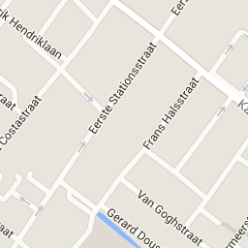

Anne van herwijnen Yara’s mother: My mother lived in a house with 4 people herself, her dad, her younger brother and a younger sister. She was the oldest. Her father was a bank manager. She lived in Hasselt on the Gaffel 16. Fall of the Berlin wall, this had a great impact on my mother. She thought it was a great development!
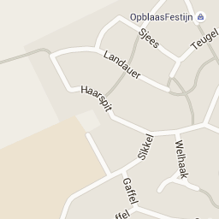

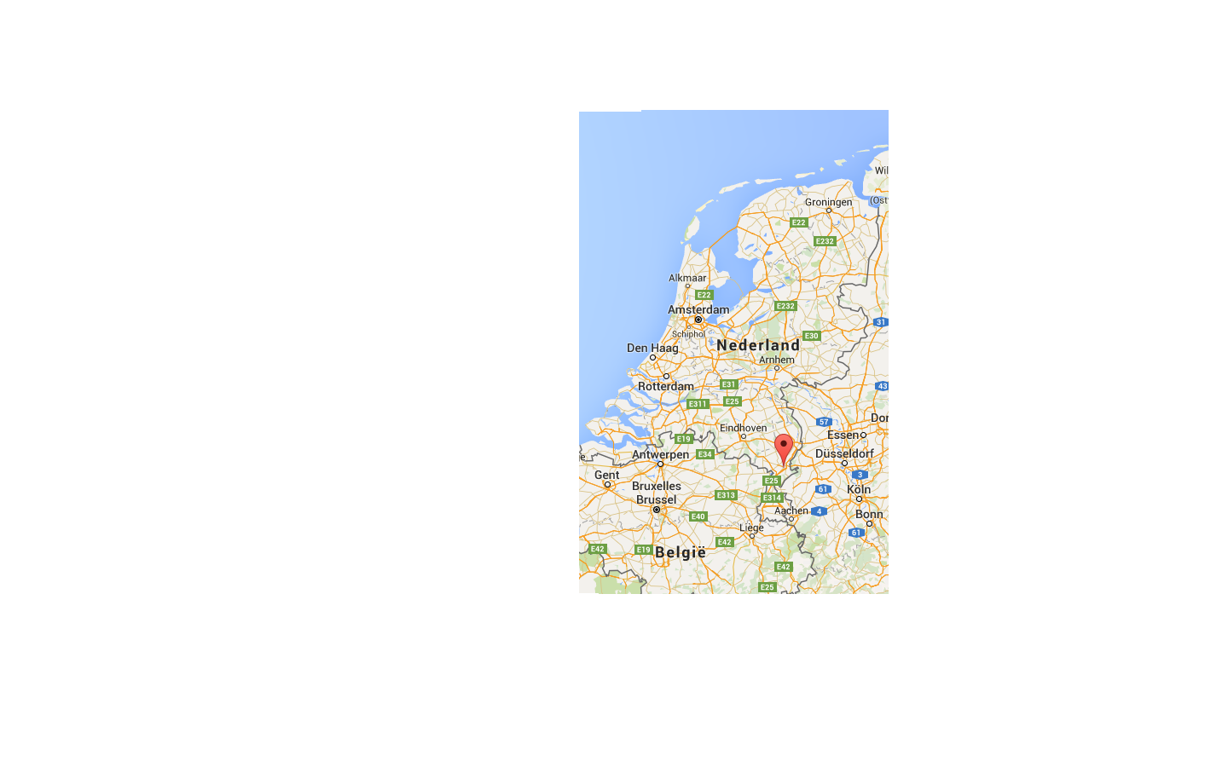
Jean Jacobs Simon’s grandfather: There were 39 people in his father’s family and 16 in his mother’s family (aunts and uncles etc included). He lived with 6 people in the same house: himself, two brothers, one sister, his mother and his father. His father was a butcher and the mother was a housewife. The historical fact that impressed him the most was when the Netherlands was in war with Indonesia. That was because he was worried about the Dutch soldiers and he knew how terrible a war is because he had experienced WW2.

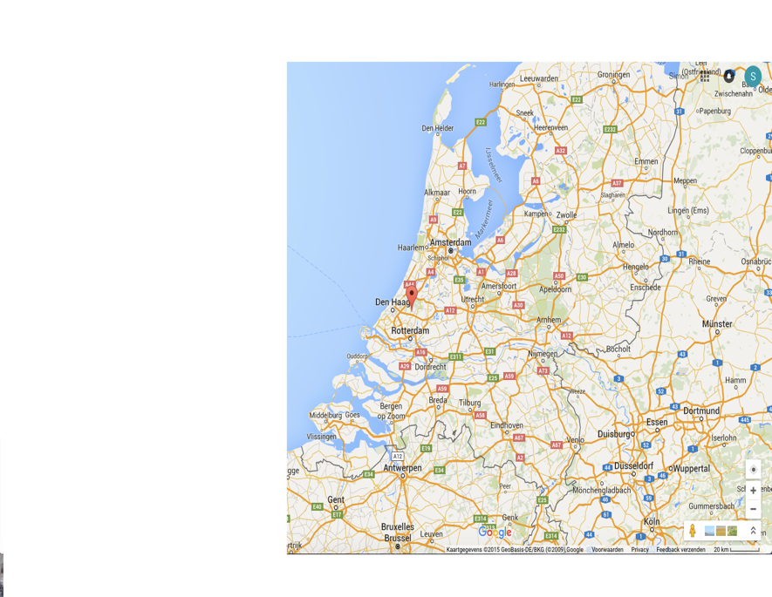
Maaike van Soest mother from Simon. Her mother’s was home to 3 people 1 mother, 1 father and one little sister. Her Father’s family was home to 5 people 1 mother, 1 father and 3 brothers (uncles and aunts etc excluded). My mother’s family lived with 4 people in the same house in Zoetermeer. My mother’s father was a chief in the royal air force and the mother was an executive secretary and an artist. She remembered the toxic gas tragedy in Bhopal in India which was in 1984 she thinks this last event impressed her the most because it was so cruel and she saw horrible pictures in the newspapers.

The interviews

We compared the parents and grandparents of course there were some differences and similarities.

Worksheet phase 2. Format similarities/differences & conclusion

1. Answers of grandparents

Similarities  1 All the grandparents had a newspaper so that was the most common form of mass media during that time.  2 They’ve all experienced WW2!  3 They all enjoyed reading, because that was the main way to collect information. | Differences  1 Mieks’s grandparent didn’t have a radio and the newspaper was still rear. This is because Mieke’s grandmother is a bit older then Yara’s and Simon’s.  2 The families differed because Mieke’s grandmother had a very large family with a lot of brothers and sister and Yara’s grandmother did not  3 There is a difference in financial situations, so that creates a difference in mass media as well
Conclusion answers grandparents
Mass media wasn’t as much time consuming as it is now. That means less communication, and slower communication. There weren’t any negative sides about mass media because when there was a sort of media it was only seen as fun!

2. Answers of parents

Similarities  1 All the parents were able of using TV, radio and newspapers.  2 All the parents think everything has changed a lot. Communication is a lot easier/faster for example.  3 All parents did not have internet and a computer. | Differences  1 Simon’s mother was able to get books from an proper library, Mieke’s mother was not really able to get books.  2 Mieke’s mother read a lot less than Simon’s mother. Maybe Mieke’s mother had less spare time.  3 could not find more differences.
Conclusion answers parents
Most things were about the same, but there were some minor differences. All parents were quit rich I guess, some people might have experienced that era different. But our parents had a good life.

3. Compare the answers of the grandparents and the parents

Similarities  1 The parents and the grandparents both had newspapers  2 The parents and the grandparents both think that the new technology is positive  3 AS well as that the parents and grandparents think the new technology is a good thing. Both groups still think that it can be very busy with all the news. | Differences  1 the grandparents read more books than the parents. Because the parents had TV  2 the parents had a bigger variety of shows they could listen to on the radio  3 the parents are better with internet while the grandparents still find it a bit difficult
Conclusion answers grandparents – parents
When the grandparents were teenagers and the parents were teenagers a lot has changed. Like when the grandparents where teenagers it was very special to have a radio. While when the parents were teenagers it was very normal to have a radio. Both one thing stayed the same and that was the use of the newspaper.

4. Conclusion. Answers to main question
Books had changed a lot. After the second world war when the grandparents were teenagers it was very difficult to find books because there were no good libraries. While when the parents were teenagers it was easy to find books except for Mieke’s mother. Media changed a lot as well now a dayfor example all most all teenagers in the Netherlands have a laptop, a smartphone, television etc so it easier to find news. But when the grandparents and parents where teenager you couldn’t search it on the internet you have to go to a library or listen to the radio. So yes media and books have changed a lot but not always in a good way.

